**Node.js Rest APIs example with Express, Sequelize & MySQL**

[Last modified: August 17, 2021](https://www.bezkoder.com/node-js-express-sequelize-mysql/)  [bezkoder](https://www.bezkoder.com/author/bezkoder/)  [Node.js](https://www.bezkoder.com/category/node-js/)

[Express](https://expressjs.com/) is one of the most popular web frameworks for Node.js that supports routing, middleware, view system… [Sequelize](https://sequelize.org/) is a promise-based Node.js ORM that supports the dialects for Postgres, MySQL, SQL Server… In this tutorial, I will show you step by step to build Node.js Restful CRUD API using Express, Sequelize with MySQL database.

You should install MySQL in your machine first. The installation instructions can be found at [Official MySQL installation manual](https://dev.mysql.com/doc/refman/5.7/en/installing.html).

Related Posts:  
– [Build Node.js Rest APIs with Express & MySQL (without Sequelize)](https://bezkoder.com/node-js-rest-api-express-mysql/)  
– [Node.js: Upload/Import Excel file data into MySQL Database](https://bezkoder.com/node-js-upload-excel-file-database/)  
– [Node.js: Upload CSV file data into MySQL Database](https://bezkoder.com/node-js-upload-csv-file-database/)

Fullstack:  
– [Vue.js + Node.js + Express + MySQL example](https://bezkoder.com/vue-js-node-js-express-mysql-crud-example/)  
– [Vue.js + Node.js + Express + MongoDB example](https://bezkoder.com/vue-node-express-mongodb-mevn-crud/)  
– [Angular 8 + Node.js Express + MySQL example](https://bezkoder.com/angular-node-express-mysql/)  
– [Angular 10 + Node.js Express + MySQL example](https://bezkoder.com/angular-10-node-js-express-mysql/)  
– [Angular 11 + Node.js Express + MySQL example](https://bezkoder.com/angular-11-node-js-express-mysql/)  
– [Angular 12 + Node.js Express + MySQL example](https://bezkoder.com/angular-12-node-js-express-mysql/)  
– [React + Node.js + Express + MySQL example](https://bezkoder.com/react-node-express-mysql/)  
– [React Redux + Node.js Express + MySQL example](https://www.bezkoder.com/react-redux-mysql-crud/)

Security: [Node.js – JWT Authentication & Authorization example](https://bezkoder.com/node-js-jwt-authentication-mysql/)  
Deployment:  
– [Deploying/Hosting Node.js app on Heroku with MySQL database](https://bezkoder.com/deploy-node-js-app-heroku-cleardb-mysql/)  
– [Dockerize Node.js Express and MySQL example – Docker Compose](https://www.bezkoder.com/docker-compose-nodejs-mysql/)

**Contents**[[hide](https://www.bezkoder.com/node-js-express-sequelize-mysql/)]

* [Node.js Rest CRUD API overview](https://www.bezkoder.com/node-js-express-sequelize-mysql/#Nodejs_Rest_CRUD_API_overview)
* [Demo Video](https://www.bezkoder.com/node-js-express-sequelize-mysql/#Demo)
* [Create Node.js App](https://www.bezkoder.com/node-js-express-sequelize-mysql/#Create_Nodejs_App)
* [Setup Express web server](https://www.bezkoder.com/node-js-express-sequelize-mysql/#Setup_Express_web_server)
* [Configure MySQL database & Sequelize](https://www.bezkoder.com/node-js-express-sequelize-mysql/#Configure_MySQL_database_038_Sequelize)
* [Initialize Sequelize](https://www.bezkoder.com/node-js-express-sequelize-mysql/#Initialize_Sequelize)
* [Define the Sequelize Model](https://www.bezkoder.com/node-js-express-sequelize-mysql/#Define_the_Sequelize_Model)
* [Create the Controller](https://www.bezkoder.com/node-js-express-sequelize-mysql/#Create_the_Controller)
  + [Create a new object](https://www.bezkoder.com/node-js-express-sequelize-mysql/#Create_a_new_object)
  + [Retrieve objects (with condition)](https://www.bezkoder.com/node-js-express-sequelize-mysql/#Retrieve_objects_with_condition)
  + [Retrieve a single object](https://www.bezkoder.com/node-js-express-sequelize-mysql/#Retrieve_a_single_object)
  + [Update an object](https://www.bezkoder.com/node-js-express-sequelize-mysql/#Update_an_object)
  + [Delete an object](https://www.bezkoder.com/node-js-express-sequelize-mysql/#Delete_an_object)
  + [Delete all objects](https://www.bezkoder.com/node-js-express-sequelize-mysql/#Delete_all_objects)
  + [Find all objects by condition](https://www.bezkoder.com/node-js-express-sequelize-mysql/#Find_all_objects_by_condition)
* [Define Routes](https://www.bezkoder.com/node-js-express-sequelize-mysql/#Define_Routes)
* [Test the APIs](https://www.bezkoder.com/node-js-express-sequelize-mysql/#Test_the_APIs)
* [Source code](https://www.bezkoder.com/node-js-express-sequelize-mysql/#Source_code)
* [Conclusion](https://www.bezkoder.com/node-js-express-sequelize-mysql/#Conclusion)
* [Further Reading](https://www.bezkoder.com/node-js-express-sequelize-mysql/#Further_Reading)

**Node.js Rest CRUD API overview**

We will build Rest Apis that can create, retrieve, update, delete and find Tutorials by title.

First, we start with an Express web server. Next, we add configuration for MySQL database, create Tutorial model with Sequelize, write the controller. Then we define routes for handling all CRUD operations (including custom finder).

The following table shows overview of the Rest APIs that will be exported:

| **Methods** | **Urls** | **Actions** |
| --- | --- | --- |
| GET | api/tutorials | get all Tutorials |
| GET | api/tutorials/:id | get Tutorial by id |
| POST | api/tutorials | add new Tutorial |
| PUT | api/tutorials/:id | update Tutorial by id |
| DELETE | api/tutorials/:id | remove Tutorial by id |
| DELETE | api/tutorials | remove all Tutorials |
| GET | api/tutorials/published | find all published Tutorials |
| GET | api/tutorials?title=[kw] | find all Tutorials which title contains 'kw' |

Finally, we’re gonna test the Rest Apis using Postman.

This is our project structure:

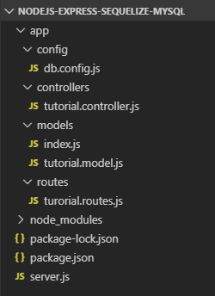

**Demo Video**

This is our Node.js Express Sequelize application demo running with MySQL database and test Rest Apis with Postman.

**Create Node.js App**

First, we create a folder:

$ mkdir nodejs-express-sequelize-mysql

$ cd nodejs-express-sequelize-mysql

Next, we initialize the Node.js App with a *package.json* file:

npm init

name: (nodejs-express-sequelize-mysql)

version: (1.0.0)

description: Node.js Rest Apis with Express, Sequelize & MySQL.

entry point: (index.js) server.js

test command:

git repository:

keywords: nodejs, express, sequelize, mysql, rest, api

author: bezkoder

license: (ISC)

Is this ok? (yes) yes

We need to install necessary modules: express, sequelize, mysql2.  
Run the command:

npm install express sequelize mysql2 cors --save

The *package.json* file should look like this:

{

"name": "nodejs-express-sequelize-mysql",

"version": "1.0.0",

"description": "Node.js Rest Apis with Express, Sequelize & MySQL",

"main": "server.js",

"scripts": {

"test": "echo \"Error: no test specified\" && exit 1"

},

"keywords": [

"nodejs",

"express",

"rest",

"api",

"sequelize",

"mysql"

],

"author": "bezkoder",

"license": "ISC",

"dependencies": {

"cors": "^2.8.5",

"express": "^4.17.1",

"mysql2": "^2.0.2",

"sequelize": "^5.21.2"

}

}

**Setup Express web server**

In the root folder, let’s create a new *server.js* file:

const express = require("express");

const cors = require("cors");

const app = express();

var corsOptions = {

origin: "http://localhost:8081"

};

app.use(cors(corsOptions));

// parse requests of content-type - application/json

app.use(express.json());

// parse requests of content-type - application/x-www-form-urlencoded

app.use(express.urlencoded({ extended: true }));

// simple route

app.get("/", (req, res) => {

res.json({ message: "Welcome to bezkoder application." });

});

// set port, listen for requests

const PORT = process.env.PORT || 8080;

app.listen(PORT, () => {

console.log(`Server is running on port ${PORT}.`);

});

What we do are:  
– import express, and cors modules:

* Express is for building the Rest apis
* [cors](https://www.npmjs.com/package/cors) provides Express middleware to enable CORS with various options.

– create an Express app, then add body-parser (json and urlencoded) and cors middlewares using app.use() method. Notice that we set origin: http://localhost:8081.  
– define a GET route which is simple for test.  
– listen on port 8080 for incoming requests.

Now let’s run the app with command: node server.js.  
Open your browser with url <http://localhost:8080/>, you will see:

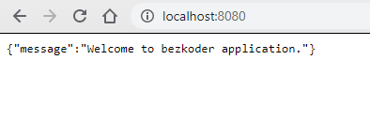

Yeah, the first step is done. We’re gonna work with Sequelize in the next section.

**Configure MySQL database & Sequelize**

In the *app* folder, we create a separate *config* folder for configuration with *db.config.js* file like this:

module.exports = {

HOST: "localhost",

USER: "root",

PASSWORD: "123456",

DB: "testdb",

dialect: "mysql",

pool: {

max: 5,

min: 0,

acquire: 30000,

idle: 10000

}

};

First five parameters are for MySQL connection.  
pool is optional, it will be used for Sequelize connection pool configuration:

* max: maximum number of connection in pool
* min: minimum number of connection in pool
* idle: maximum time, in milliseconds, that a connection can be idle before being released
* acquire: maximum time, in milliseconds, that pool will try to get connection before throwing error

For more details, please visit [API Reference for the Sequelize constructor](https://sequelize.org/master/class/lib/sequelize.js~Sequelize.html#instance-constructor-constructor).

**Initialize Sequelize**

We’re gonna initialize Sequelize in **app**/**models** folder that will contain model in the next step.

Now create **app**/**models**/*index.js* with the following code:

const dbConfig = require("../config/db.config.js");

const Sequelize = require("sequelize");

const sequelize = new Sequelize(dbConfig.DB, dbConfig.USER, dbConfig.PASSWORD, {

host: dbConfig.HOST,

dialect: dbConfig.dialect,

operatorsAliases: false,

pool: {

max: dbConfig.pool.max,

min: dbConfig.pool.min,

acquire: dbConfig.pool.acquire,

idle: dbConfig.pool.idle

}

});

const db = {};

db.Sequelize = Sequelize;

db.sequelize = sequelize;

db.tutorials = require("./tutorial.model.js")(sequelize, Sequelize);

module.exports = db;

Don’t forget to call sync() method in *server.js*:

...

const app = express();

app.use(...);

const db = require("./app/models");

db.sequelize.sync();

...

In development, you may need to drop existing tables and re-sync database. Just use force: true as following code:

db.sequelize.sync({ force: true }).then(() => {

console.log("Drop and re-sync db.");

});

**Define the Sequelize Model**

In *models* folder, create *tutorial.model.js* file like this:

module.exports = (sequelize, Sequelize) => {

const Tutorial = sequelize.define("tutorial", {

title: {

type: Sequelize.STRING

},

description: {

type: Sequelize.STRING

},

published: {

type: Sequelize.BOOLEAN

}

});

return Tutorial;

};

This Sequelize Model represents **tutorials** table in MySQL database. These columns will be generated automatically: *id*, *title*, *description*, *published*, *createdAt*, *updatedAt*.

After initializing Sequelize, we don’t need to write CRUD functions, Sequelize supports all of them:

* create a new Tutorial: [create](https://sequelize.org/master/class/lib/model.js~Model.html#static-method-create)(object)
* find a Tutorial by id: [findByPk](https://sequelize.org/master/class/lib/model.js~Model.html#static-method-findByPk)(id)
* get all Tutorials: [findAll](https://sequelize.org/master/class/lib/model.js~Model.html#static-method-findAll)()
* update a Tutorial by id: [update](https://sequelize.org/master/class/lib/model.js~Model.html#static-method-update)(data, where: { id: id })
* remove a Tutorial: [destroy](https://sequelize.org/master/class/lib/model.js~Model.html#static-method-destroy)(where: { id: id })
* remove all Tutorials: destroy(where: {})
* find all Tutorials by title: findAll({ where: { title: ... } })

These functions will be used in our Controller.

We can improve the example by adding Comments for each Tutorial. It is the One-to-Many Relationship and I write a tutorial for this at:  
[Sequelize Associations: One-to-Many example – Node.js, MySQL](https://bezkoder.com/sequelize-associate-one-to-many/)

Or you can add Tags for each Tutorial and add Tutorials to Tag (Many-to-Many Relationship):  
[Sequelize Many-to-Many Association example with Node.js & MySQL](https://bezkoder.com/sequelize-associate-many-to-many/)

**Create the Controller**

Inside **app**/**controllers** folder, let’s create *tutorial.controller.js* with these CRUD functions:

* create
* findAll
* findOne
* update
* delete
* deleteAll
* findAllPublished

const db = require("../models");

const Tutorial = db.tutorials;

const Op = db.Sequelize.Op;

// Create and Save a new Tutorial

exports.create = (req, res) => {

};

// Retrieve all Tutorials from the database.

exports.findAll = (req, res) => {

};

// Find a single Tutorial with an id

exports.findOne = (req, res) => {

};

// Update a Tutorial by the id in the request

exports.update = (req, res) => {

};

// Delete a Tutorial with the specified id in the request

exports.delete = (req, res) => {

};

// Delete all Tutorials from the database.

exports.deleteAll = (req, res) => {

};

// Find all published Tutorials

exports.findAllPublished = (req, res) => {

};

Let’s implement these functions.

**Create a new object**

Create and Save a new Tutorial:

exports.create = (req, res) => {

// Validate request

if (!req.body.title) {

res.status(400).send({

message: "Content can not be empty!"

});

return;

}

// Create a Tutorial

const tutorial = {

title: req.body.title,

description: req.body.description,

published: req.body.published ? req.body.published : false

};

// Save Tutorial in the database

Tutorial.create(tutorial)

.then(data => {

res.send(data);

})

.catch(err => {

res.status(500).send({

message:

err.message || "Some error occurred while creating the Tutorial."

});

});

};

**Retrieve objects (with condition)**

Retrieve all Tutorials/ find by title from the database:

exports.findAll = (req, res) => {

const title = req.query.title;

var condition = title ? { title: { [Op.like]: `%${title}%` } } : null;

Tutorial.findAll({ where: condition })

.then(data => {

res.send(data);

})

.catch(err => {

res.status(500).send({

message:

err.message || "Some error occurred while retrieving tutorials."

});

});

};

We use req.query.title to get query string from the Request and consider it as condition for findAll() method.

**Retrieve a single object**

Find a single Tutorial with an id:

exports.findOne = (req, res) => {

const id = req.params.id;

Tutorial.findByPk(id)

.then(data => {

res.send(data);

})

.catch(err => {

res.status(500).send({

message: "Error retrieving Tutorial with id=" + id

});

});

};

**Update an object**

Update a Tutorial identified by the id in the request:

exports.update = (req, res) => {

const id = req.params.id;

Tutorial.update(req.body, {

where: { id: id }

})

.then(num => {

if (num == 1) {

res.send({

message: "Tutorial was updated successfully."

});

} else {

res.send({

message: `Cannot update Tutorial with id=${id}. Maybe Tutorial was not found or req.body is empty!`

});

}

})

.catch(err => {

res.status(500).send({

message: "Error updating Tutorial with id=" + id

});

});

};

**Delete an object**

Delete a Tutorial with the specified id:

exports.delete = (req, res) => {

const id = req.params.id;

Tutorial.destroy({

where: { id: id }

})

.then(num => {

if (num == 1) {

res.send({

message: "Tutorial was deleted successfully!"

});

} else {

res.send({

message: `Cannot delete Tutorial with id=${id}. Maybe Tutorial was not found!`

});

}

})

.catch(err => {

res.status(500).send({

message: "Could not delete Tutorial with id=" + id

});

});

};

**Delete all objects**

Delete all Tutorials from the database:

exports.deleteAll = (req, res) => {

Tutorial.destroy({

where: {},

truncate: false

})

.then(nums => {

res.send({ message: `${nums} Tutorials were deleted successfully!` });

})

.catch(err => {

res.status(500).send({

message:

err.message || "Some error occurred while removing all tutorials."

});

});

};

**Find all objects by condition**

Find all Tutorials with published = true:

exports.findAllPublished = (req, res) => {

Tutorial.findAll({ where: { published: true } })

.then(data => {

res.send(data);

})

.catch(err => {

res.status(500).send({

message:

err.message || "Some error occurred while retrieving tutorials."

});

});

};

This controller can be modified a little to return pagination response:

{

"totalItems": 8,

"tutorials": [...],

"totalPages": 3,

"currentPage": 1

}

You can find more details at:  
[Server side Pagination in Node.js with Sequelize and MySQL](https://bezkoder.com/node-js-sequelize-pagination-mysql/)

**Define Routes**

When a client sends request for an endpoint using HTTP request (GET, POST, PUT, DELETE), we need to determine how the server will reponse by setting up the routes.

These are our routes:

* /api/tutorials: GET, POST, DELETE
* /api/tutorials/:id: GET, PUT, DELETE
* /api/tutorials/published: GET

Create a *turorial.routes.js* inside *app/routes* folder with content like this:

module.exports = app => {

const tutorials = require("../controllers/tutorial.controller.js");

var router = require("express").Router();

// Create a new Tutorial

router.post("/", tutorials.create);

// Retrieve all Tutorials

router.get("/", tutorials.findAll);

// Retrieve all published Tutorials

router.get("/published", tutorials.findAllPublished);

// Retrieve a single Tutorial with id

router.get("/:id", tutorials.findOne);

// Update a Tutorial with id

router.put("/:id", tutorials.update);

// Delete a Tutorial with id

router.delete("/:id", tutorials.delete);

// Delete all Tutorials

router.delete("/", tutorials.deleteAll);

app.use('/api/tutorials', router);

};

You can see that we use a controller from /controllers/tutorial.controller.js.

We also need to include routes in *server.js* (right before app.listen()):

...

require("./app/routes/turorial.routes")(app);

// set port, listen for requests

const PORT = ...;

app.listen(...);

**Test the APIs**

Run our Node.js application with command: node server.js.  
The console shows:

Server is running on port 8080.

Executing (default): DROP TABLE IF EXISTS `tutorials`;

Executing (default): CREATE TABLE IF NOT EXISTS `tutorials` (`id` INTEGER NOT NULL auto_increment , `title` VARCHAR(255), `description` VARCHAR(255), `published` TINYINT(1), `createdAt` DATETIME NOT NULL, `updatedAt` DATETIME NOT NULL, PRIMARY KEY (`id`)) ENGINE=InnoDB;

Executing (default): SHOW INDEX FROM `tutorials`

Drop and re-sync db.

Using Postman, we’re gonna test all the Apis above.

1. **Create a new Tutorial using POST /tutorials Api**

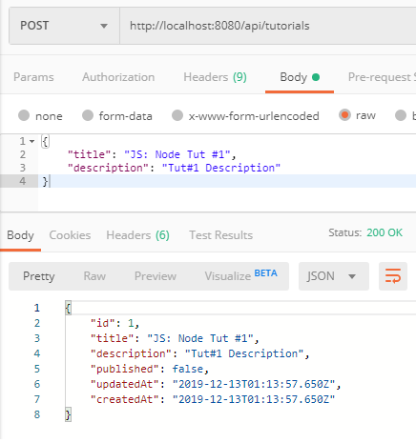

After creating some new Tutorials, you can check MySQL table:

mysql> select * from tutorials;

+----+-------------------+-------------------+-----------+---------------------+---------------------+

| id | title | description | published | createdAt | updatedAt |

+----+-------------------+-------------------+-----------+---------------------+---------------------+

| 1 | JS: Node Tut #1 | Tut#1 Description | 0 | 2019-12-13 01:13:57 | 2019-12-13 01:13:57 |

| 2 | JS: Node Tut #2 | Tut#2 Description | 0 | 2019-12-13 01:16:08 | 2019-12-13 01:16:08 |

| 3 | JS: Vue Tut #3 | Tut#3 Description | 0 | 2019-12-13 01:16:24 | 2019-12-13 01:16:24 |

| 4 | Vue Tut #4 | Tut#4 Description | 0 | 2019-12-13 01:16:48 | 2019-12-13 01:16:48 |

| 5 | Node & Vue Tut #5 | Tut#5 Description | 0 | 2019-12-13 01:16:58 | 2019-12-13 01:16:58 |

+----+-------------------+-------------------+-----------+---------------------+---------------------+

1. **Retrieve all Tutorials using GET /tutorials Api**

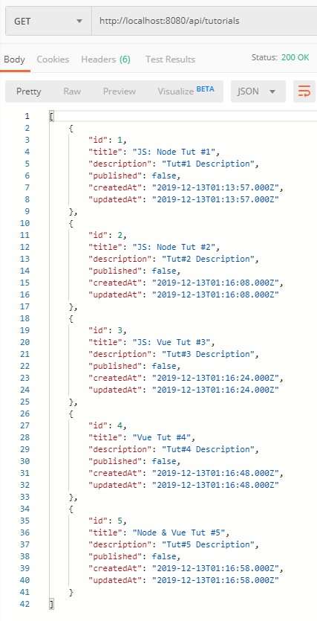

1. **Retrieve a single Tutorial by id using GET /tutorials/:id Api**

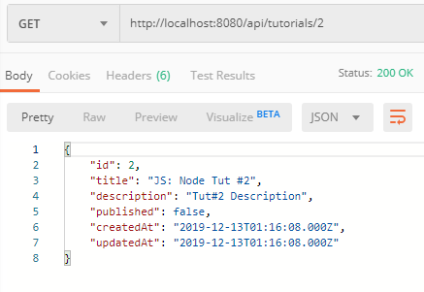

1. **Update a Tutorial using PUT /tutorials/:id Api**

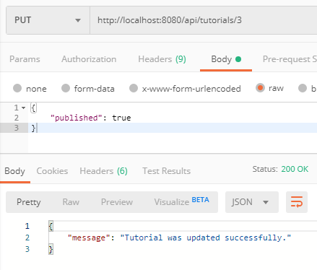

Check tutorials table after some rows were updated:

mysql> select * from tutorials;

+----+-------------------+-------------------+-----------+---------------------+---------------------+

| id | title | description | published | createdAt | updatedAt |

+----+-------------------+-------------------+-----------+---------------------+---------------------+

| 1 | JS: Node Tut #1 | Tut#1 Description | 0 | 2019-12-13 01:13:57 | 2019-12-13 01:13:57 |

| 2 | JS: Node Tut #2 | Tut#2 Description | 0 | 2019-12-13 01:16:08 | 2019-12-13 01:16:08 |

| 3 | JS: Vue Tut #3 | Tut#3 Description | 1 | 2019-12-13 01:16:24 | 2019-12-13 01:22:51 |

| 4 | Vue Tut #4 | Tut#4 Description | 1 | 2019-12-13 01:16:48 | 2019-12-13 01:25:28 |

| 5 | Node & Vue Tut #5 | Tut#5 Description | 1 | 2019-12-13 01:16:58 | 2019-12-13 01:25:30 |

+----+-------------------+-------------------+-----------+---------------------+---------------------+

1. **Find all Tutorials which title contains ‘node’: GET /tutorials?title=node**

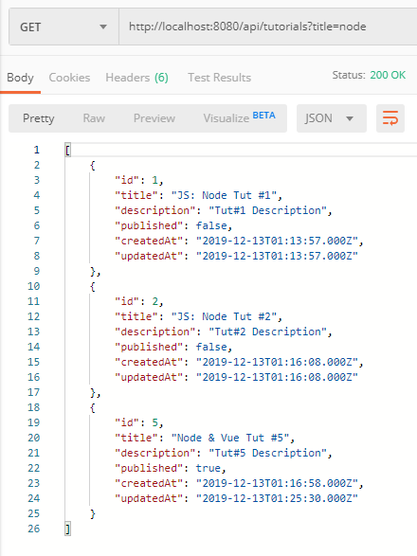

1. **Find all published Tutorials using GET /tutorials/published Api**

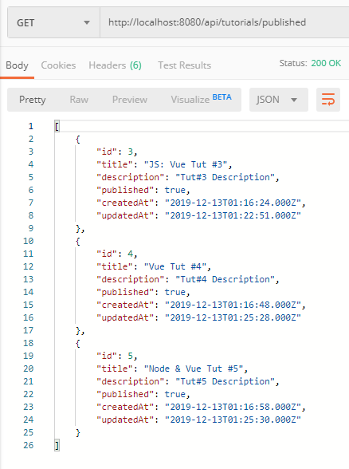

1. **Delete a Tutorial using DELETE /tutorials/:id Api**

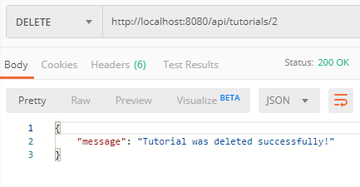

Tutorial with id=2 was removed from tutorials table:

mysql> select * from tutorials;

+----+-------------------+-------------------+-----------+---------------------+---------------------+

| id | title | description | published | createdAt | updatedAt |

+----+-------------------+-------------------+-----------+---------------------+---------------------+

| 1 | JS: Node Tut #1 | Tut#1 Description | 0 | 2019-12-13 01:13:57 | 2019-12-13 01:13:57 |

| 3 | JS: Vue Tut #3 | Tut#3 Description | 1 | 2019-12-13 01:16:24 | 2019-12-13 01:22:51 |

| 4 | Vue Tut #4 | Tut#4 Description | 1 | 2019-12-13 01:16:48 | 2019-12-13 01:25:28 |

| 5 | Node & Vue Tut #5 | Tut#5 Description | 1 | 2019-12-13 01:16:58 | 2019-12-13 01:25:30 |

+----+-------------------+-------------------+-----------+---------------------+---------------------+

1. **Delete all Tutorials using DELETE /tutorials Api**

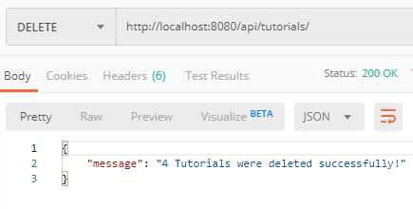

Now there are no rows in tutorials table:

mysql> SELECT * FROM tutorials;

Empty set (0.00 sec)

Or you can use the [Simple HTTP Client using Axios](https://www.bezkoder.com/axios-request/) to check it.

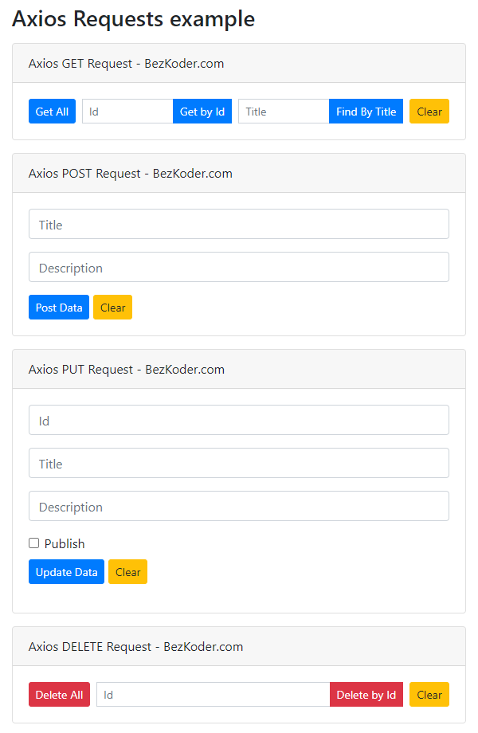

**Conclusion**

Today, we’ve learned how to create Node.js Rest Apis with an Express web server. We also know way to add configuration for MySQL database & Sequelize, create a Sequelize Model, write a controller and define routes for handling all CRUD operations.

You can find more interesting thing in the next tutorial:  
– [Server side Pagination in Node.js with Sequelize and MySQL](https://bezkoder.com/node-js-sequelize-pagination-mysql/)  
Return pagination data in response:

{

"totalItems": 8,

"tutorials": [...],

"totalPages": 3,

"currentPage": 1

}

– [Deploying/Hosting Node.js app on Heroku with MySQL database](https://bezkoder.com/deploy-node-js-app-heroku-cleardb-mysql/)

Or you can save Image to MySQL database:  
[Upload/store images in MySQL using Node.js, Express & Multer](https://bezkoder.com/node-js-upload-image-mysql/)

Happy learning! See you again.

**Further Reading**

* [Express.js Routing](https://expressjs.com/en/guide/routing.html)
* <https://www.npmjs.com/package/express>
* <https://www.npmjs.com/package/body-parser>
* <https://www.npmjs.com/package/mysql2>
* [Tutorials and Guides for Sequelize v5](https://sequelize.org/master/)

Upload Tutorial data from file to MySQL database table:

* [Node.js: Upload Excel file data into MySQL Database](https://bezkoder.com/node-js-upload-excel-file-database/)
* [Node.js: Upload CSV file data into MySQL Database](https://bezkoder.com/node-js-upload-csv-file-database/)

Fullstack CRUD Application:  
– [Vue.js + Node.js + Express + MySQL example](https://bezkoder.com/vue-js-node-js-express-mysql-crud-example/)  
– [Vue.js + Node.js + Express + MongoDB example](https://bezkoder.com/vue-node-express-mongodb-mevn-crud/)  
– [Angular 8 + Node.js Express + MySQL example](https://bezkoder.com/angular-node-express-mysql/)  
– [Angular 10 + Node.js Express + MySQL example](https://bezkoder.com/angular-10-node-js-express-mysql/)  
– [Angular 11 + Node.js Express + MySQL example](https://bezkoder.com/angular-11-node-js-express-mysql/)  
– [Angular 12 + Node.js Express + MySQL example](https://bezkoder.com/angular-12-node-js-express-mysql/)  
– [React + Node.js + Express + MySQL example](https://bezkoder.com/react-node-express-mysql/)  
– [React Redux + Node.js Express + MySQL example](https://www.bezkoder.com/react-redux-mysql-crud/)

File Upload Rest API:  
– [Node.js Express File Upload Rest API example using Multer](https://www.bezkoder.com/node-js-express-file-upload/)  
– [Google Cloud Storage with Node.js: File Upload example](https://www.bezkoder.com/google-cloud-storage-nodejs-upload-file/)

Deployment:  
– [Deploying/Hosting Node.js app on Heroku with MySQL database](https://bezkoder.com/deploy-node-js-app-heroku-cleardb-mysql/)  
– [Dockerize Node.js Express and MySQL example – Docker Compose](https://www.bezkoder.com/docker-compose-nodejs-mysql/)

**Source code**

You can find the complete source code for this example on [Github](https://github.com/bezkoder/nodejs-express-sequelize-mysql).

If you want to add Comments for each Tutorial. It is the One-to-Many Association, there is a tutorial for that Relationship: [Sequelize Associations: One-to-Many example – Node.js, MySQL](https://bezkoder.com/sequelize-associate-one-to-many/)

Or you can add Tags for each Tutorial and add Tutorials to Tag (Many-to-Many Relationship):  
[Sequelize Many-to-Many Association example with Node.js & MySQL](https://bezkoder.com/sequelize-associate-many-to-many/)

Using SQL Server instead: [Node.js CRUD example with SQL Server (MSSQL)](https://www.bezkoder.com/node-js-sql-server-crud/)